Objectives:
- The robot will grab the foam object periodically from top to bottom with sufficient overlap.
- The gelsight in the arm will collect the gelsight data for every grab and estimate depth
- The data will have the gelsight position and orientation and image from the camera to verify the process.

Process:

- The foam object is in a fixed position set up by screwing the base on the table. The position is known. This fixed position is used to make the robot go to that position and grab the object.
- Mechanism of the robot step by step:
  - Robot will rotate 90 degrees
  - Open the gripper
  - Get at the top of the foam object while the gripper is on
  - Close the gripper so that the gelsight is touching the object. Stay like this for 1 second and collect both gelsight rgb image and RealSense rgb image data.
  - Close the gripper to 1mm from both sides to grab the object strongly. Stay like this for 1 second and collect both gelsight rgb image and RealSense rgb image data.
  - Open the gripper sufficiently so the gripper is not touching the object anymore. Keep collecting data.
  - Go down by 2 mm. Then repeat the steps from d to f.
  - After completing 40 steps like this, go back to the home position.
- Collected Data:
  - Data is only collected when the robot is not moving.
  - Every second 30 different samples are taken.
  - Each step included Open → Initial touch → Press. All those sub steps were 1 second long. So each step included 90 gelsight images and 90 realsense camera images.
Open:
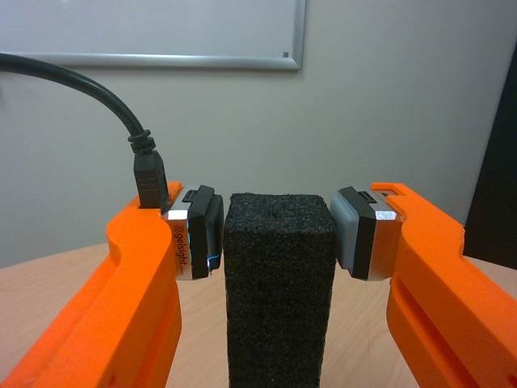
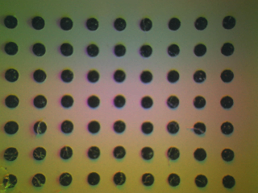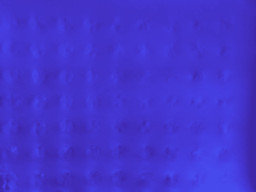
Initial Touch:
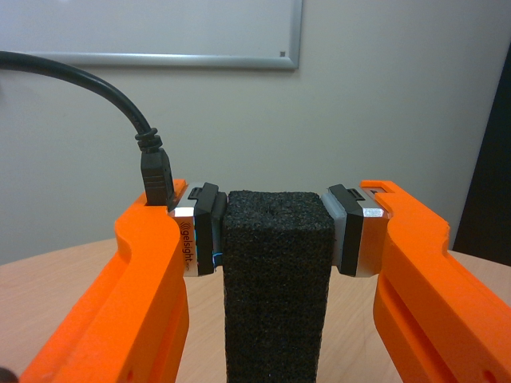
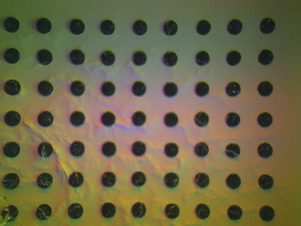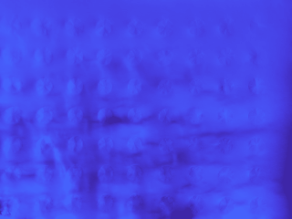
Pressing:
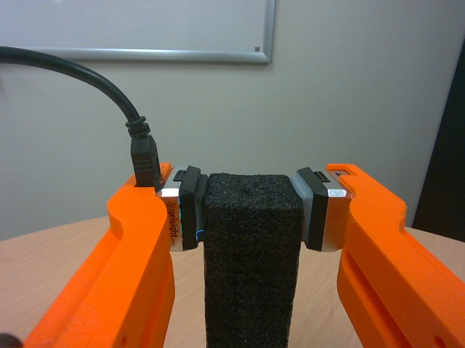
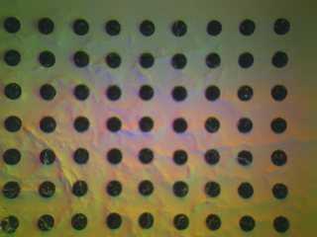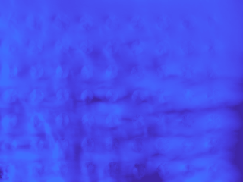

  - Later depth estimation was applied on all the saved gelsight images and depth color image and raw depth map were saved.
  - For each single data also contained
    - Corresponding cartesian position and quaternion orientation
    - Cartesian coordinates of 4 corner position
    - Time Stamp in UTC format: (e.g. "2025-11-19T22:49:29.190Z")
    - Separate exact time stamp for gelsight image and realsense image
    - The instance of the gripper if it was open, or initial touch or closed
    - The x coordinate of the boundary to verify if the robot is touching the object.
    - The difference between the x coordinate of the robot and the x coordinate of the boundary of the object.

Calibration:

Gelsight coordinate with respect to base:
The end-effector coordinate can be easily found directly from the API. So the modified end-effector coordinates were measured from this:

pose6 = driver.get_cartesian_positions()
u = driver.get_gripper_position()
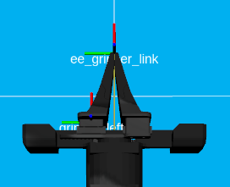

The above is the robot’s default gripper when the gripper is closed. The transformation from the end-effector to the gripper to the last joint (only when the gripper is closed) was measured from the robot configuration. This is a fixed transformation.

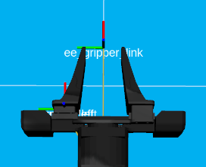

Then the gripper was opened by a fixed offset and using that the moving joint position’s transformation was measured. This will move with respect to how much the gripper is open. The fixed offset can be found by this function.

u = driver.get_gripper_position()
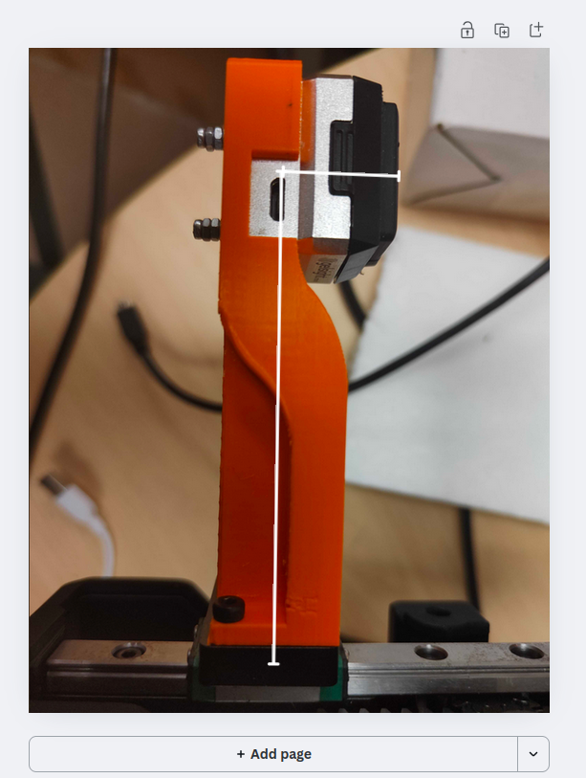

Then manually this distance was measured to find the transformation of the end-effector. So using the end-effector and gripper position the transformation to the modified end-effector from the default end-effector was achieved.

Getting Camera Coordinates:

The left side of the camera in the robot captures the colored image and the right side of the camera captures IR images. The camera is fixed with link 6 and also with the default end-effector.

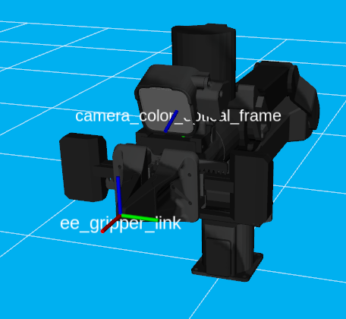

So from the configuration of the robot the end-effector to the camera transformation is measured which is a constant value.

T_base_to_camera = T_base_to_ee * T_ee_to_camera

So using this camera to base transformation can be achieved for any position of the robot.

Modified End-Effector Calibration:
Assuming the modified end-effector was not accurate the end-effector was further calibrated using the camera. The gelsight’s 4 corner point with respect to it’s center was measured.
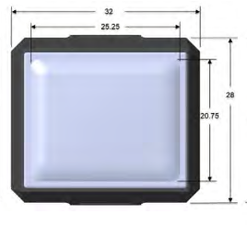
Those inner points can be seen from the camera. But the distinct points are not at the same plane as the gelsight as the sensor is a little convex. The points’s 3D coordinate with respect to the gelsight was measured with depth.

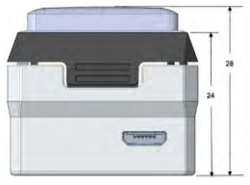
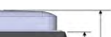

But those 4 corner points are on the same plane. First those points were projected on the image plane found from the kinematics.

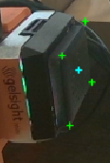

Then the points were clicked from the image and were solved using the PnP method. Which gave an extra transformation matrix Delta_T which included in the calculation of the modified end-effector. Even it was done with the 4 corner points the modified end-effector is actually the enter of the gelsight

Later the gripper was moved to specific gripper positions and the 4 corner points were clicked in all those points. And the difference between them was calculated.

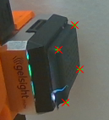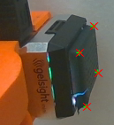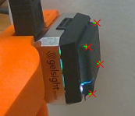

Below is a list of the errors:

Gripper Opening (u) | Translation Δp (Δx,Δy,Δz) (m)
0.042 m (42 mm) | [-0.000394, -0.000270, 0.000772]
0.040 m (40 mm) | [0.000105, 0.000036, -0.000064]
0.038 m (38 mm) | [-0.000335, -0.000226, 0.000261]
0.036 m (36 mm) | [-0.000750, -0.000445, 0.000359]
0.034 m (34 mm) | [0.000122, -0.000266, -0.000238]
0.032 m (32 mm) | [0.001149, -0.000026, -0.000764]
0.030 m (30 mm) | [0.000928, -0.000438, -0.000672]
0.028 m (28 mm) | [0.000691, -0.000535, -0.000617]
0.026 m (26 mm) | [0.001995, -0.000649, -0.000818]

Object Localization:
The object was fixed to the table using screws and drill. Then the object was looked at from the camera and 4 points were selected. The dimension of the object was also measured and used to calculate the 4 corner points of the object with respect to the base. Those 4 corner points create the boundary of the object.

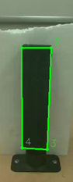

The following are the 4 corner points of the object with respect to the base. Top left, then top right, then bottom right and then bottom left.
Top left: [ 0.01972 -0.41683 0.18438]
Top right: [-0.01877 -0.41644 0.18391]
Bottom right: [-0.01692 -0.4139 0.03469]
Bottom left: [ 0.02057 -0.41429 0.03516]

From the above we can see that the front of the object is a plane which has an approximately constant y value. In this case
y represents the depth of the object seen from camera
Z represents the height
X represents the horizontal distance

The robot will touch the left edge of the object. So the top left and the bottom left points are important. From the top left and the bottom left points we can find a straight line with the variable x and z, as the value of x remains approximately constant.

Verifying if the robot is touching the object:
When the robot is touching the object the robot’s (x,y,z) can be found. The gelsight’s y and the boundary’s y will be different as the robot is touching the object a little deeper than the boundary. But the x and z coordinates should match. So from the z coordinate found from the robot’s end-effector was used in the straight line above. And from that straight line the x value of the boundary was measured. Then the difference between the boundary x and the robot x was calculated which was found to be around 0.3 mm when the robot is touching the object.

Four Corners of the gelsight:
The 4 corners of the gelsight were calculated from the center. These corner points are different from the corner points that were used to do the calibration. Rather they are found from the field of view which was collected from the datasheet.

Field of View 18.6(H) x 14.3(V) mm

Data Saving:
Data was saved every 0.0333 seconds. There are multiple threads going on in parallel. Gelsight RGB image is collected and stored in a variable. Each time a new gelsight image arrives the variable updates. Same with the RealSense RGB image. Every 0.0333 second the latest gelsight image, the latest realsense image, and the latest calculated coordinate is collected and saved as the same frame number. There were some instances where the same gelsight image was stored in consecutive two frames. But overall the gelsight image collection frequency was found to be around 18 Hz. This was collected using the exact timestamp of the gelsight image. And the realsense image frequency was found to be around 29 Hz.

This data was organized in a session_log.csv file for better visibility. Every row in the file contains data for every frame. The last 3 columns contain the file names of the gelsight rgb images, depth color images and realsense rgb images.

